**ASSIGNMENT 1**

**Submitted by:**

**Lavanya Lavanya**

**Student ID: 22077323**

**Submitted to:**

**Professor: Nawaz Chowdhury**

**Subject: Computer environment and tooling**

**Course code: CSD113**

Honesty Statement: “I declare that this submission is my work in compliance with Sault College Academic Policies.”

**Due date: 12 January 2024**

Contents

Lab Instructions 5

Step 1: 5

Step 2: 6

Step 3: 7

Step 4: 7

References: 8

Table of Figures

Figure 1 Basic Template Created 5

Figure 2 Insert Button Working 6

Figure 3: Insert Button Inserted New Row 7

Figure 4:Delete Row Button Is Working 8

# **Lab Instructions**

## Step 1:

Created Basic Template Mentioned in the Assignment and did some basic styling of page and table

.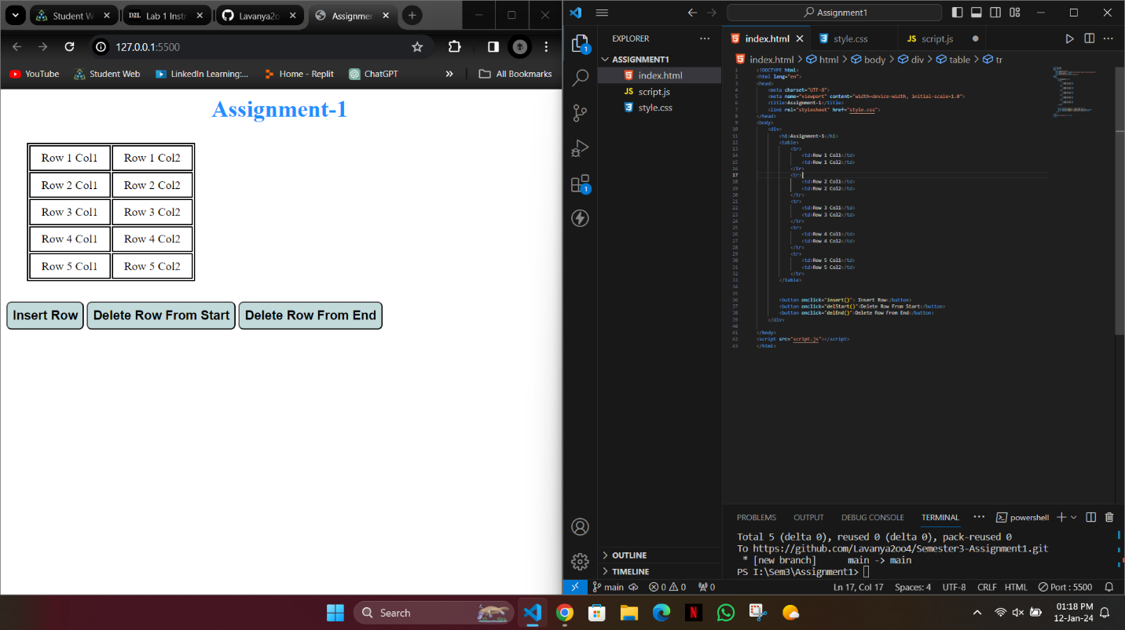

Figure Basic Template Created

## Step 2:

After Creating the Basic Template started working on the buttons and wrote code to make insert button work.

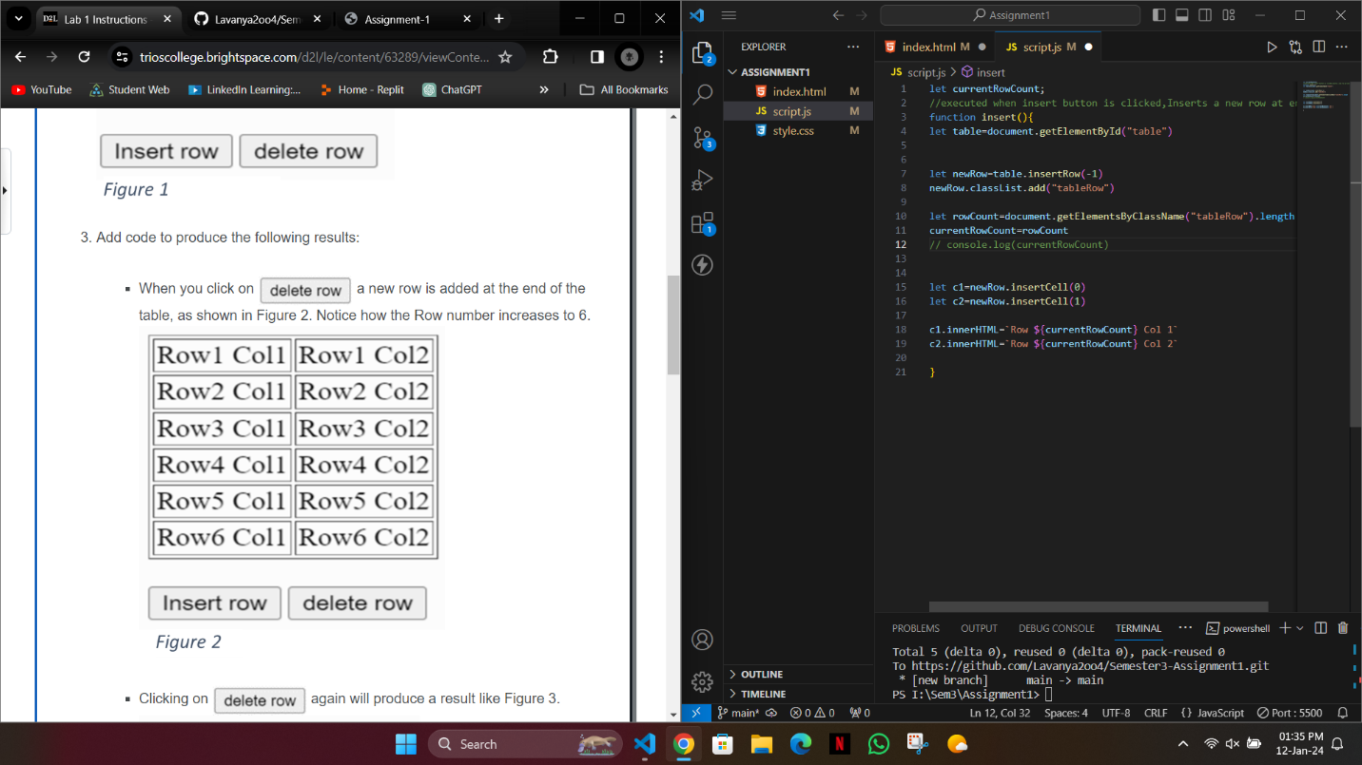

Figure Insert Button Working

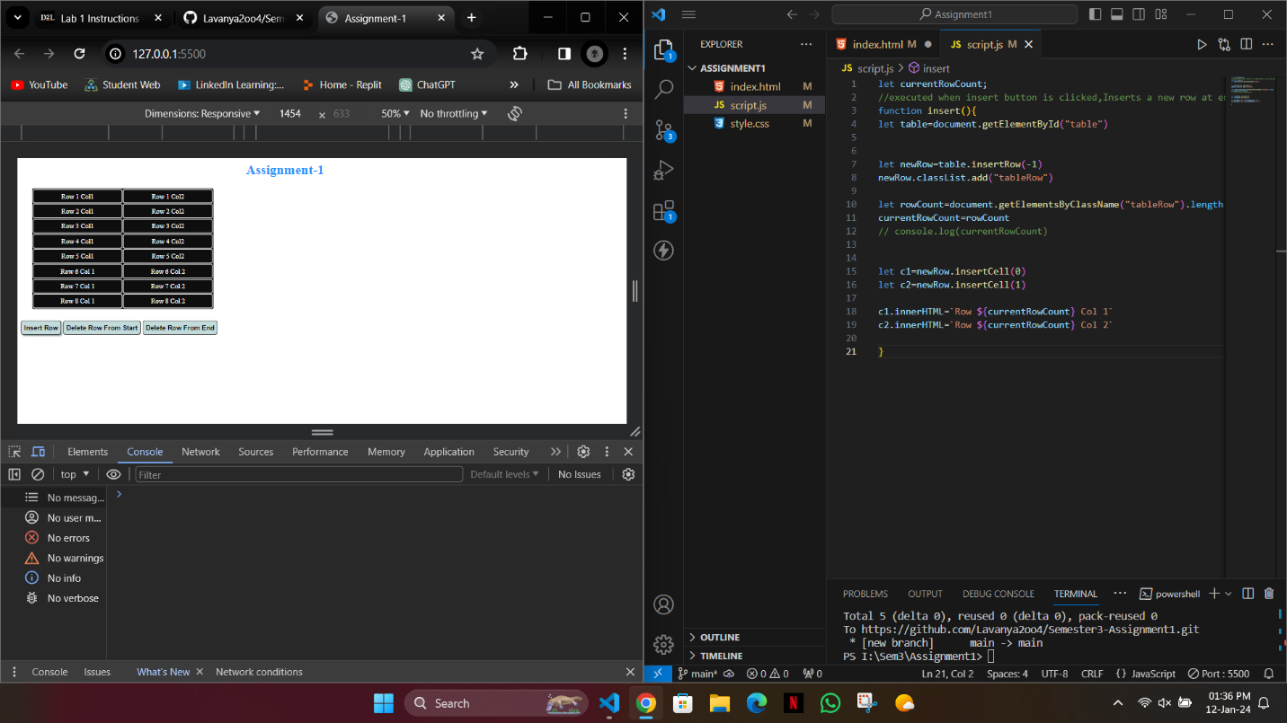

Figure : Insert Button Inserted New Row

## Step 3:

Wrote code to Delete Rows From Start and From End

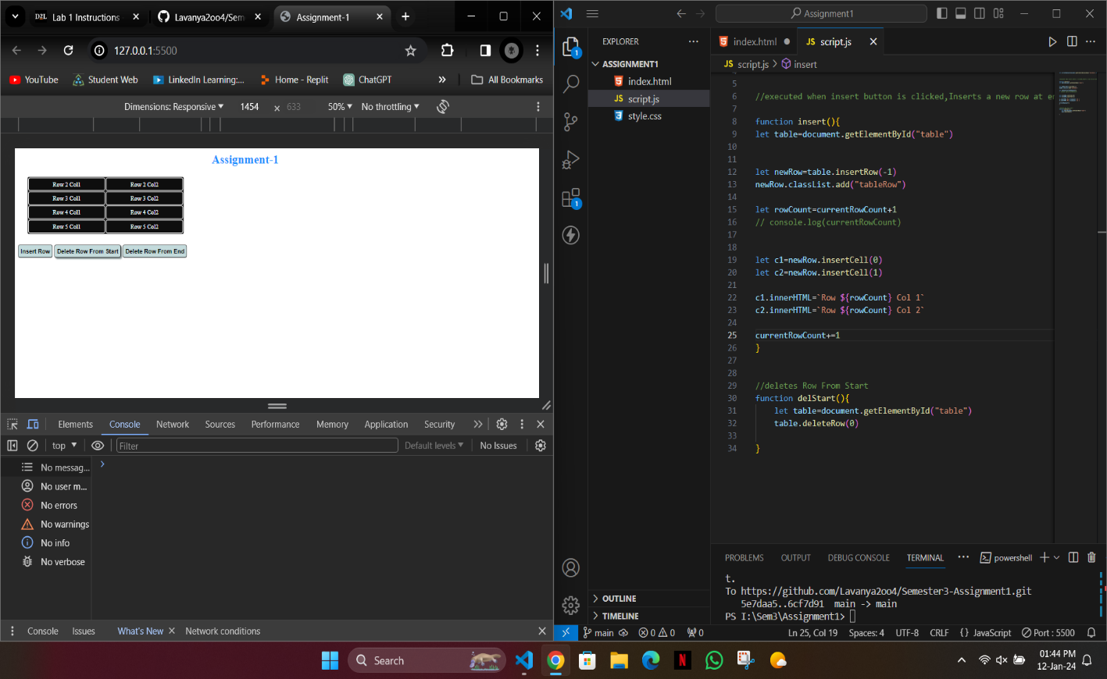

Figure :Delete Row Button Is Working

## Step 4:

Git hub link given below

https://github.com/Lavanya2oo4/Semester3-Assignment1.git

# References:

1. “W3Schools Online HTML Editor.” *Www.w3schools.com*, www.w3schools.com/jsref/tryit.asp?filename=tryjsref_table_insert_deleterow. Accessed 12 Jan. 2024.
2. “How to Add Rows to a Table Using JavaScript DOM?” *Www.tutorialspoint.com*, www.tutorialspoint.com/How-to-add-rows-to-a-table-using-JavaScript-DOM.